Assignment 2 Due: March 14, 2014

This assignment will give you some experience writing and running SQL queries on a large data warehouse. You will use Teradata's SQL Assistant  WEB Edition, a browser-based relational database query tool. You will use it to query the Sam's Club database that contains over 1 million records. In the web interface, you should set the database name to be **ua_samsclub**. The database schema diagram follows.

Use the following url to access the database: <http://teradata.waltoncollege.uark.edu/login.aspx>

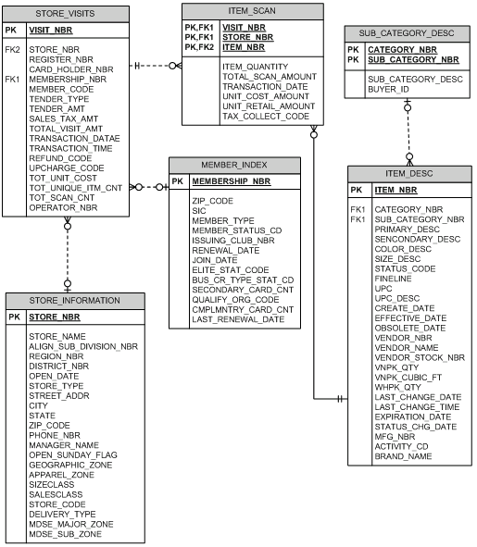

**Note:** In the STORE_VISITS table, the column TRANSACTION_DATAE should be TRANSACTION_DATE.

Each group will have to write the following 8 queries. To get the most out of this assignment, one group member should be responsible for writing queries 1 through 4 and other for writing queries 5 through 8. However, group members may help each other with their queries. The point value for each query is shown in parentheses.

**Query 1 (5)**: List the stores (number and name) located in Florida and the sum of the total_visit_amt for each store and order the result by store number.

**NOTE:** Even though there are 17 stores in FL, only 3 of them have STORE_VISITS information but all 17 have ITEM_SCAN information.

**Query 2 (20)**: List by week (i.e., week 1, 2, 3, …) for the month of January 2000, the Florida stores (number) and the sum of total_visit_amt for each store. In this query result we also want

* the sum for each week for all stores as well as the sum for each store
* the sum for each store for all weeks
* the sum for all weeks and all stores

Order the result by week number and store number**.**

**Query 3 (20)**: List by week (i.e., week 1, 2, 3, …) for the month of January 2000, the Florida stores (number) and the weekly sales sum of total_visit_amt for each store along with the Rank of the sales for the week (where a rank of 1 is for the store with the highest sales in that week) for the Florida stores.

Order the result by week number and store number.

**Query 4 (5)**: List the member numbers for members who have visited a particulare store more than 1,000 times. Order the result by store_nbr and membership_nbr.

**Query 5 (5):** List the store number and the number of visits by customers for the store with the most visits.

**Query 6 (10)**: Find members that have visited more than 10 different stores. Include membership_nbr and their count of stores visited.

**Query 7 (20)**: Which item (item_nb , upc_desc) sold the most, sum(item_quantity), in each week in the month of January 2000 for Florida stores?

**Query 8 (15)**: Which vendors (vendor number) supply more than 6% of the unique items that are sold at that store ( store number) in Florida?

After you execute each query, you should copy it from the query window and paste it into a word document. Also include the output from each query. Each group member will submit the complete document of 8 queries via Tsquare by March 14th at 5PM. Be sure to specify which 4 queries you were responsible for writing.

**The metadata for the Sam's Club database is shown below.**

|  |  |  |
| --- | --- | --- |
| **Attribute** | **Description** | **Values** |
| ACTIVITY_CD | Activity Code | Y, N |
| BRAND_NAME | Name of the brand associated with the item | Null, name of brand |
| BUS_CR_TYP_STAT_CD | Business Credit Type Status Code | 0-10 |
| CARD_HOLDER_NBR | Card holder within an account | 1-99 |
| CATEGORY_NBR | Number assigned to a category of items | Null, 0-99 |
| CMPLMNTRY_CARD_CNT | Number of extra cards given to an account | 0-4 |
| COLOR_DESC | Color description of an item | White, Almond, etc |
| CREATE_DATE | Date the item was created | Date |
| EFFECTIVE_DATE | Date the item began to be sold | Date |
| ELITE_STAT_CODE |  | 0-4 |
| EXPIRATION_DATE | Expiration date of an item | Date |
| FINELINE | Combination of category_nbr & sub_category_nbr | 4 digit number |
| ISSUING_CLUB_NBR | The club that the member originally joined | 1-150 |
| ITEM_NBR | The number assigned to every different item for sale | Unique number (PK) |
| ITEM_QUANTITY | The quantity of a unique item that is scanned |  |
| JOIN_DATE | Date the member joined the club | Date |
| LAST_RENEWAL_DATE | Last date that the member renewed their membership | Date |
| MEMBER_CODE |  | 1,A,D,E,G,V,W,X,Y |
| MEMBER_STATUS_CD |  | A,D,E,T |
| MEMBER_TYPE |  | 1,A,E,G,V,W,X |
| MEMBERSHIP_NBR | The number assigned to the member upon joining the club |  |
| MFG_NBR | Number representing a manufacturer |  |
| OBSOLETE_DATE | The date an item is no longer sold | Date |
| OPERATOR_NBR |  |  |
| PRIMARY_DESC | The description of an item | Teal X-Large etc |
| QUALIFY_ORG_CODE |  | Null, 015-3001 |
| REFUND_CODE | Code to indicate a return transaction | 0 = Not Return, 1= Return |
| REGISTER_NBR | The register identification number where the transaction took place | 1-85 |
| RENEWAL_DATE | Date a membership should be renewed | Date |
| SALES_TAX_AMT | Tax charged for total visit |  |
| SECONDARY_CARD_CNT | Number of cards other than primary card assigned to the membership |  |
| SECONDARY_DESC | Additional description of an item | Sweatshirt, gift set etc |
| SIC | Standard Industry Classification code | 783700, 443700 etc |
| SIZE_DESC | Text description of the size of the item, including clothing and non-clothing items | 15CUFT, LARGE, etc |
| STATUS_CHG_DATE | The date an item last changed its status code | Date |
| STATUS_CODE | Whether an item is active or deactive | A = Active, D = Deactive |
| STORE_NAME | The name of the store |  |
| STORE_NBR | Store identification number | 1-150 |
| SUB_CATEGORY_NBR | The number assigned to a sub_category of items |  |
| TAX_COLLECT_CODE | Purchase taxable or not | 0,1 |
| TENDER_AMT | The amount tendered for the purchase |  |
| TENDER_TYPE | Type of payment used | 0 - Cash 1 - Check 2 - Gift Card 3 - Discover 4 - Direct Credit 5 - Business Credit 6 - Personal Credit |
| TOT_SCAN_CNT | Total number of scanned items per transaction |  |
| TOT_UNIQUE_ITM_CNT | The number of unique items purchased per transaction | 0-84 |
| TOT_UNIT_COST | The cost of the item (scrubbed) |  |
| TOTAL_SCAN_AMOUNT | The total number of items scanned per visit number |  |
| TOTAL_VISIT_AMT | The total value of the entire transaction |  |
| TRANSACTION_DATE | Date of the transaction |  |
| TRANSACTION_TIME | The time of day that the transaction started |  |
| UNIT_COST_AMOUNT | Cost/Unit (scrubbed) |  |
| UNIT_RETAIL_AMOUNT | Purchase Price/Unit (scrubbed) |  |
| VENDOR_NBR | The number of the vendor that supplies the item |  |
| VISIT_NBR | Every time a member goes to the register and has their membership card scanned, this number is then created | 9 digit # |
| VNPK_CUBIC_FT | How many cubic feet does a vendor pack take up |  |
| VNPK_QTY | The quantity of items in a vendor pack |  |
| ZIP_CODE | The zip-code of the store |  |
| ZIP_CODE | The zip-code of the member |  |